Outputs and Screenshots of Program

Outputs

1. When the program will start running, this will be first screen which comes to appear as shown below...

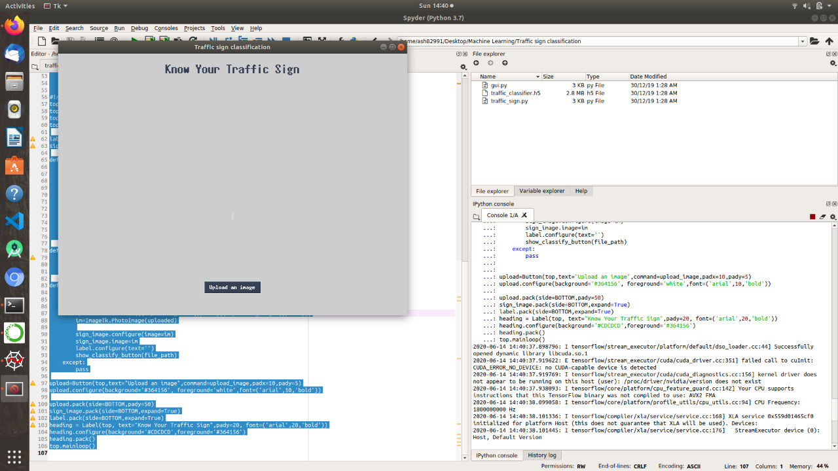

1. You will need to select the sign image of which classification needs; this can be done by clicking on Upload Image and choose the image, it is also shown in image below…

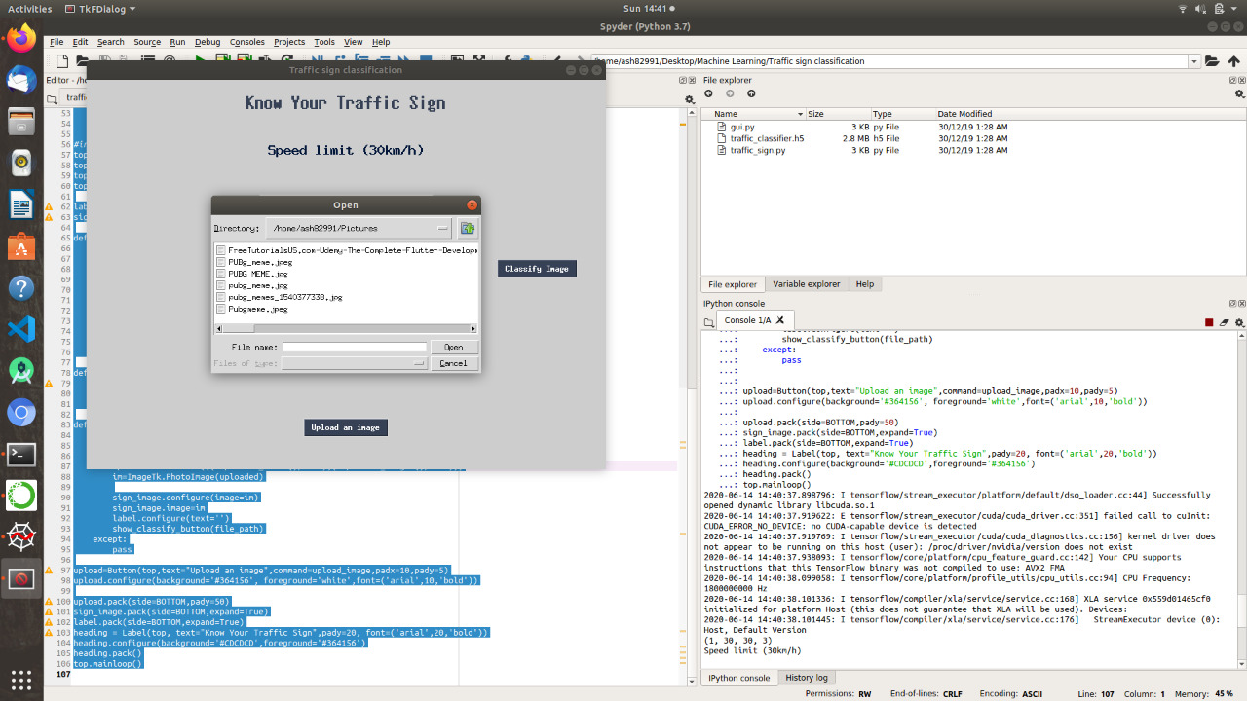

1. For example, a 30 Km Speed limit image is taken into account. Then click on **Classify Image** for the classification of image. Here, in this case, it is a 30 Km speed limiter.

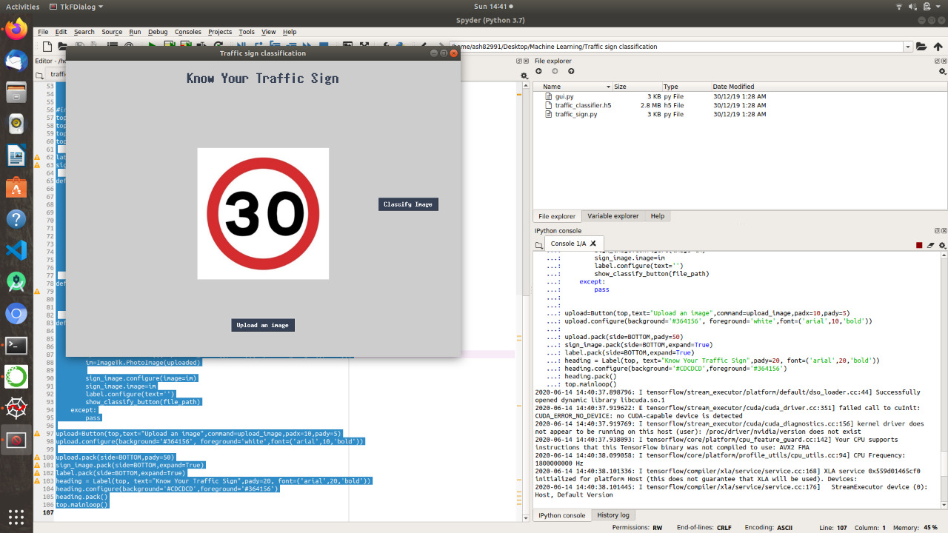

1. After Clicking on **Classify Image,** the project starts to classify the image, and just above the image the classification will get shown and also the colour of **Classify Image** will get changed. For more clarification look into the image shown below:

